Task/Description: Hot Works
Assessed By: | Alasdair Ewen | Approved By:
Assessment Date: | 11th April 2023 | Review Date: 11th April 2026  (Review not to exceed 3 years from assessment date)
For specific risks we MUST have specific assessments – such as COSHH, DSE, Fire, Manual Handling, the business has specific forms for such RA’s, which should be referenced in the ‘Additional Information’ column.

Hazard Identification – Indicate which of the following hazards are considered in this assessment
Access or egress |  | Harmful/Toxic substances |  | Power operated tools or machinery | x
Asbestos |  | Hazard to other activities | x | Pressure (implosion/explosion/high pressure system)
Biological agent/hazard |  | Hazards from other activities |  | Radiation (Ionising/non-ionising)
Confined space |  | Hot works/radiant heat | x | Remotely operated machinery
Corrosive/Irritant/Sensitising Substance |  | Impact/Contact hazards |  | Rotating Parts (Entanglement)
Crush hazards |  | Lasers |  | Slip trips and falls
Dust/particles | x | Lead |  | Stored energy
Electrical | x | Lighting |  | Temperature (hot/cold environment/surfaces)
Ergonomic factors (repetitive/posture/stretching) |  | Lone working |  | Traps/nips
Excavations |  | Manual handling |  | Underground services
Falling or flying objects |  | Mobile plant |  | Vapours/Mists
Falls from height |  | Needle stick or Sharps |  | Vehicle/Plant Movements
Fire or explosion | x | Noise |  | Ventilation | x
Flames, sparks radiant heat | x | Overhead services |  | Vibration (whole body/hand-arm)
Flammable Substances |  | Pace of Work |  | Violence/abuse/assault
Fumes | x | Pedestrian access and egress |  | Weather conditions
Hand operated tools or machinery | x | Pedestrian movement |  | Working near water
Harmful or explosive gases |  | Pneumatic tools/compressed air |  | Other (please state) – Source of blinding light (arc eye) | x

Hazard No. | Record Significant Hazards | Person(s) at Risk | Existing Control Measures | Initial  Risk Rating |  |  | Additional Control Measures | Residual  Risk Rating |  |  |  | Additional  Information
 |  |  |  | S | L | R |  | S | L | R
 | Provide specific details. E.g. ‘work at height” say how high. E.g. “Electricity” state voltage and type of hazard, Striking underground services | Who might be harmed and how E.g. “Contractor or Employee Fall from Height” | Detail existing control measures.  These are the controls that are currently in place | S – Severity  L – Likelihood  R - Risk |  |  | Detail additional control measures needed to eliminate hazard completely or minimise risk to acceptable level.  (Include in Action Plan) | S – Severity  L – Likelihood  R - Risk |  |  |  | Cross Reference & Additional  Information e.g. SSW,
H1 | Fire or Explosion  - Welding sparks igniting flammable materials or gases/liquids | PHS Engineer  Client  Employees  - Burns  - Percussive injuries | - Engineers trained, experienced and signed off as competent to perform hot works.  - Area to be welded closely inspected for cleanliness, and free from oils and grease.  - All flammable materials, gas bottles, drums etc to be cleared a minimum of 3m away from work area  - Welding PPE as stated in MS to be worn. | 5 | 2 | 10
H2 | Flames/Sparks/ Radiant heat  - Material ignited by welding sparks/heat  - Sparks flying out from welding area  - Radiant heat from welded area | PHS Engineer  Client  Employees  - burns | - Area to be welded closely inspected for cleanliness, and free from oils and grease.  - All flammable materials, gas bottles, drums etc to be cleared a minimum of 3m away from work area  - Welding screen to be used to shield other areas from sparks/welding arc.  - Welded area allowed time to cool before barriers/screens removed  . | 4 | 2 | 8
H3 | Fumes  - Fumes generated by welding rod  - Fumes generated from area being welded (e.g., burning paint) | PHS Engineer  Client  Employees  - Inhalation of welding fumes can cause respiratory issues. | - Air-fed welding mask to EN175, EN 379, EN166 to be worn  - Adequate ventilation available at the worksite. Portable LEV may be used where appropriate, or equipment must be moved to a suitable area.  - Paint, oils and grease to be removed from area to be welded before work carried out. | 3 | 2 | 6
H4 | Hot works/ Radiant Heat  - Fumes from welding process  - Radiant heat from welded parts  - Eye injury from welding arc | PHS Engineer  Client  Employees | - Covered in separate entries on this RA  - H3 Fumes, H6 Ventilation  - H2 Flames/Sparks/Radiant Heat  - H7 Injury from welding arc | 3 | 2 | 6
H5 | Power operated tools  - Welding arc uses high voltages/current | PHS Engineer  Client  Employees  - Risk of electrocution or burns from equipment | - All equipment to be thoroughly inspected for damage before and after each use  - Damaged equipment must not be used under any circumstances. | 4 | 2 | 8
H6 | Other: Lack of Ventilation  - Any fumes that would reduce oxygen in area | PHS Engineer  Client  Employees  - Respiratory issues  - Environmental | - Adequate ventilation should be available at the worksite. Portable LEV may be used where appropriate, or equipment must be moved to a suitable area.  - Open external doors/windows to disperse fumes | 4 | 2 | 8
H7 | Other – Source of blinding light  - Risk of “arc-eye” from welding arc | PHS Engineer  Client  Employees  - All persons in vicinity not wearing EN379 eye protection | - Work area to be cleared of all non-essential personnel.  - Welding screen(s) to be erected around work area | 4 | 2 | 8
H8 | Emergency Procedures | PHS Engineer  Clients Employees | - Please refer to RA for Emergency Procedures | 5 | 2 | 10 |  |  |  |  | - RA0024 Emergency Procedures

ACTION PLAN

Task | Risk | What further action do you need to take to control the risk? | By whom | Due Date | Date Complete
1
2
3
4
5
6
7
8
9
10
11
12
13
14
15
16
17
18
19
20
21

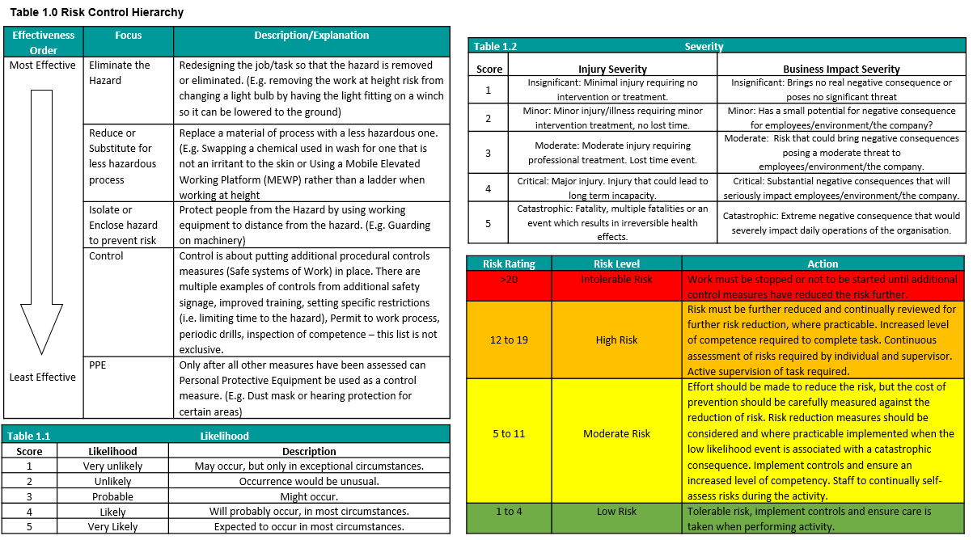

Risk Assessment Sign Off Sheet

Site Name |  | Site Manager
RA Title / Reference No. | RA0011 Hot works | RA Version Number | 1
I have received training as to the hazards relating to the process/area, as outlined in the Risk Assessment and the control measures I should use to work safely. In the event of any queries I am aware I should stop work and speak to my supervisor or line manager.

Name | Signature | Date

