Task/Description: Servicing Machinery
Assessed By: | Trevor Wratten | Approved By: John Haddow
Assessment Date: | 11th April 2023 | Review Date: 11th April 2026  (Review not to exceed 3 years from assessment date)
For specific risks we MUST have specific assessments – such as COSHH, DSE, Fire, Manual Handling, the business has specific forms for such RA’s, which should be referenced in the ‘Additional Information’ column.

Hazard Identification – Indicate which of the following hazards are considered in this assessment
Access or egress |  | Harmful/Toxic substances |  | Power operated tools or machinery
Asbestos |  | Hazard to other activities |  | Pressure (implosion/explosion/high pressure system) | x
Biological agent/hazard |  | Hazards from other activities |  | Radiation (Ionising/non-ionising)
Confined space | x | Hot works/radiant heat |  | Remotely operated machinery
Corrosive/Irritant/Sensitising Substance | x | Impact/Contact hazards |  | Rotating Parts (Entanglement) | x
Crush hazards |  | Lasers |  | Slip trips and falls | x
Dust/particles | x | Lead |  | Stored energy | x
Electrical | x | Lighting | x | Temperature (hot/cold environment/surfaces)
Ergonomic factors (repetitive/posture/stretching) | x | Lone working | x | Traps/nips
Excavations |  | Manual handling | x | Underground services
Falling or flying objects |  | Mobile plant |  | Vapours/Mists | x
Falls from height | x | Needle stick or Sharps |  | Vehicle/Plant Movements | x
Fire or explosion |  | Noise |  | Ventilation
Flames, sparks radiant heat |  | Overhead services |  | Vibration (whole body/hand-arm)
Flammable Substances |  | Pace of Work |  | Violence/abuse/assault
Fumes |  | Pedestrian access and egress |  | Weather conditions | x
Hand operated tools or machinery | x | Pedestrian movement | x | Working near water
Harmful or explosive gases |  | Pneumatic tools/compressed air |  | Other (please state) | x

Hazard No. | Record Significant Hazards | Person(s) at Risk | Existing Control Measures | Initial  Risk Rating |  |  | Additional Control Measures | Residual  Risk Rating |  |  | Additional  Information
 |  |  |  | S | L | R |  | S | L | R
 | Provide specific details. E.g. ‘work at height” say how high. E.g. “Electricity” state voltage and type of hazard, Striking underground services | Who might be harmed and how E.g. “Contractor or Employee Fall from Height” | Detail existing control measures.  These are the controls that are currently in place | S – Severity  L – Likelihood  R - Risk |  |  | Detail additional control measures needed to eliminate hazard completely or minimise risk to acceptable level.  (Include in Action Plan) | S – Severity  L – Likelihood  R - Risk |  |  | Cross Reference & Additional  Information e.g. SSW,
H1 | Manual Handling  - Lifting and lowering (e.g. cylinders)  - carrying toolboxes/ equipment,  - pushing and pulling loads into position.  - Ergonomic positioning | PHS Engineer  - Musculoskeletal injuries or disorders | - Engineers are trained in manual handling (ROSPA accredited course)  - Manual handling training refreshed every 3yrs or sooner if needed.  - Task assessment complete as per WI 57-19/19A.  - Engineers to assess loads prior to lifting, including removal and refitting of access panels  - Engineers to not lift weights above their capacity.  - Mechanical lifting aids are available via ROC team and should be considered for use ahead of a two-person lift being implemented.  - Two-person lifting is available and should be implemented if identified through the point of work risk assessment.  - Lifts are not considered repetitive in nature as engineers are not expected to lift a load multiple times within a single hour.  - Engineers advised to avoid carrying heavy loads over substantial distances and to use mechanical lifting aids if needed. | 3 | 3 | 9 |  |  |  |  | - WI 57-19/19A.
H2 | Slip/trip/fall  - Poor Housekeeping  - Poor storage of materials.  - Slippery surfaces  - Uneven ground conditions | PHS Engineer  Clients Employees  Members of public  - Falling over/on objects  - Tripping on objects  - Slipping on surfaces | - Oil spill kits are located on Engineers vans  - Oil kits restocked when needed from stores.  - Spillages are dealt with in accordance with RA-009 Oil Spillages  - MSDS available to all engineers  - Warning signs and barriers to be used to cordon off spillage areas  - Engineers to maintain good level of housekeeping and working tidy.  - Engineers to follow clients site rules.  - Managers to periodically audit engineers  - All engineers complete ROSPA approved Workplace Slips, trips and falls course – with 3 yearly refreshers.  - Yellow Rules (H&S) training slips, trips and falls completed by all engineers  - Follow clients site rules  - Inform the client of any spillage.  - PPE: Safety footwear in line with BS EN 20345. | 3 | 2 | 6 |  |  |  |  | - RA009 Oil Spillages
H3 | Lighting:  - Poor lighting in area  - Automated lighting (switching off -whilst working) | PHS Engineer  Clients Employees  - Harm is an increase in risk from other hazards, e.g. slip trip, striking object, and others. | - Engineers instructed not to work in situations that they deem to have insufficient lighting to work safely.  - Head/hand torch provided to each engineer for specific task lighting  - Additional lighting such as stand lighting is also available if required.  - Engineers to ask client contact if they can turn off any automated lighting sensors so that lighting remains on when working on the baler. | 2 | 2 | 4
H4 | Electrical:  - Electrical shock, burns,  - Fire and explosion from electrical shortage | PHS Engineer  Clients Employees  - Electric charge/ shock injury as a result of contact with live wires/battery | - Engineers trained in safe working on electrical equipment  - All electrical hand tools are PA tested (annually) and use 24v DC, 110Vac or 230v ac with RCD (Residual Current Device) protection.  - Pre use inspection complete by engineers  - Engineers are trained in electrical safety (ROSPA Accredited) with 3 yearly refresher training.  - Engineers trained in PHS Yellow Rules – Electrical safety.  - Electrical isolation of equipment is advised prior to working on the units.  - Engineers advised to prove (Lock off Tag out) electrical contacts are dead prior to working on them.  - Method statement MS0020 to be followed to deal with potential earth faults | 5 | 1 | 5 |  |  |  |  | - RA007 working on electrical equipment  - RA0020 working on electrical circuits
H5 | Pressure:  - From loss of containment in the hydraulic system | PHS Engineer  Clients  Employees  - Hydraulic injection  - Contact with skin/eyes/ ingestion | - Engineers discharge any residual pressure from the system before working on the unit.  - Hoses are guarded – where possible.  - Hose whip cords in place where needed  - Hoses checked for damaged/deterioration on installation and during inspections.  - Defective/damaged hoses replaced.  - Non -essential persons asked to vacate the area during testing  - PPE: Nitrile gloves issued and worn by all engineers to avoid skin contact,  - PPE: Safety Glasses Compliant with EN 166 issued and worn by engineers when working on Hydraulic systems. | 4 | 1 | 4
H6 | Other: Mechanical Hazard:  - From working on the baler and interacting with components | PHS Engineer  - Crush Hazard/  - Traps/nips  - Contact with sharp | - Engineers trained in the safe procedure for changing components, use of work-place equipment.  - Engineers to ensure guarding is in place prior to energising the machine.  - PPE: Safety footwear in line with EN 20345, S1P standard.  - Safety gloves in line with EN388, OGL 2065 4.1.3.1 | 4 | 2 | 8
H7 | Weather conditions  Relevant when balers are located outside buildings. Hazards include:  - Heat  - Cold  - Wind  - Precipitation  - Lightning  - Snow and ice | PHS Engineer  - Hypothermia  - Hyperthermia  - Heat exposure  - Working in wet conditions  - Struck by lightning | - Engineers instructed to not work outside during a thunderstorm where lightning is occurring.  - Engineers instructed to take regular breaks during extremes of heat/cold in order to remain suitably warm/cool, ensuring they remain hydrated.  - Suitable clothing for the relevant environment is advised.  - Hand torches are issued and should be used to external works to ensure suitable lighting levels.  - PPE: Waterproof clothing compliant with EN343 is available for engineers to order should they require it. | 2 | 4 | 8
H8 | Fall from Height  - From use of ladders  - From use of working platforms | PHS Engineer  - Fall from height | - Engineers are trained (ROSPA accredited) in working at Height  - Engineers work in accordance with WI 57-22  - Work ladders and platforms meet at minimum EN131  - Ladders and platforms are checked in line with WI 28-01G before use  - All Engineers trained in PHS Yellow Rules: Working at Height  - All ladders and platforms are registered and tagged.  - Staff to only use ladders/platforms provided by PHS.  - Managers perform spot-check audits of equipment | 4 | 2 | 8 |  |  |  |  | - RA0013 Working at height  - WI 57-22  - WI 28-01G
H9 | Vehicle and plant movements  - Third party or PHS vehicles  - Forklift truck | PHS Engineer  - Struck by vehicle | - Only trained persons permitted to  - use vehicles owned or utilised by PHS.  - Installation teams to isolate area of install from site traffic.  - Engineers advised to remain 3m from moving vehicles and plant.  - PPE: Hi-vis clothing (EN471) | 5 | 1 | 5
H10 | Hand operated tools or machinery  - From working with tools and operating machinery | PHS Engineer  - Crush Hazard/  - Traps/nips  - Contact with sharp | - Engineers trained in the safe procedure for changing components and use of workplace equipment.  - Engineers to ensure guarding is in place prior to energising the machine.  - PPE: Safety footwear in line with EN 20345  - Safety gloves in line with EN388  - Safety Glasses Compliant with EN 166 issued and worn by engineers when working with power tools | 3 | 1 | 3
H11 | Confined Spaces | PHS Engineer  - Entrapment  - crushing  - Loss of consciousness | - Machinery must be isolated and locked off and tagged out as per training.  - Specific risks associated with task and location must be considered on PoWRA and mitigation factors considered | 5 | 1 | 5 |  |  |  |  | - RA0019 Confined spaces
H12 | Irritant Sensitising Substance  - Oils and lubes | PHS Engineer  - Contact with oils and lubes causing skin irritation | - Safety gloves in line with EN388 oil resistant gloves  - Refer to H2  - Wash skin thoroughly with soap and water if in contact with oil  - Boiler suits provided | 4 | 1 | 4
H13 | Dust/particles  - Depending on material being compacted/baled dust particles may be present | PHS Engineers  Clients’ Employees  - Contact with eyes and mucous membrane may cause irritant | - KN95 masks to be worn if dust particles present  - Goggles in line with EN166 to be worn to protect the eyes | 2 | 1 | 2
H14 | Ergonomic factors  - Repetitive  - Posture  - Stretching | PHS Engineer  - Musculoskeletal injuries or disorders | - Regular breaks  - Rotation of jobs | 2 | 4 | 8
H15 | Lone working  - Difficulty gaining assistance in an emergency | PHS Engineer  - Less chance of assistance in an emergency | - Please see RA for lone working | 4 | 1 | 4 |  |  |  |  | - RA0016 Lone working
H16 | Pedestrian movement  - Pedestrians in area of oil spill | PHS Engineer  Client  Employees  Slipping on contaminated surface | - Warning signs and barriers to be used to cordon off spillage areas  - Follow any client site rules | 5 | 1 | 5 |  |  |  |  | - RA009 Oil spillages
H17 | Stored Energy  - Heavy components could suddenly fall or move, potentially causing injury or damage to equipment | PHS Engineer  Client  - Crush injuries  - Entrapment | - Potential energy to be released before work commences:  - Hydraulic systems de-pressurised, Electrical systems de-energised.  - Heavy components to be supported or moved using approved equipment as per method statement | 5 | 1 | 5
H18 | Other - waste in around or stuck in the baler | PHS Engineer  - Weil’s disease from contact with animal faecal matter  - Hep B from contamination in waste, typically through absorption or cuts to hands allowing the contamination to the blood stream | - Hep B injection for all engineers (currently under review)  - Instruction for customer to clean baler.  - Right to challenge for customers who leave waste in baler.  - Mechanical safety gloves | 2 | 5 | 10
H19 | Emergency Procedures | PHS Engineer  Clients Employees | - Please refer to RA for Emergency Procedures | 5 | 2 | 10 |  |  |  |  | - RA0024 Emergency procedures
H20 | Access or egress  - Working on some machinery requires you to work inside of it | PHS Engineer  Clients  Employees  Members of public  - Entrapment  - Loss of consciousness  - Traps/nips | - Point of work risk assessment completed before each task (PoWRA)  - Barriers used to protect local area  - 2-man job  - PPE: bump caps in line with EN812:2012  - Mechanical lifting aids are available via ROC team and should be considered for use ahead of a two-person lift being implemented. | 5 | 1 | 5

ACTION PLAN

Task | Risk | What further action do you need to take to control the risk? | By whom | Due Date | Date Complete
1
2
3
4
5
6
7
8
9
10
11
12
13
14
15
16
17
18
19
20
21

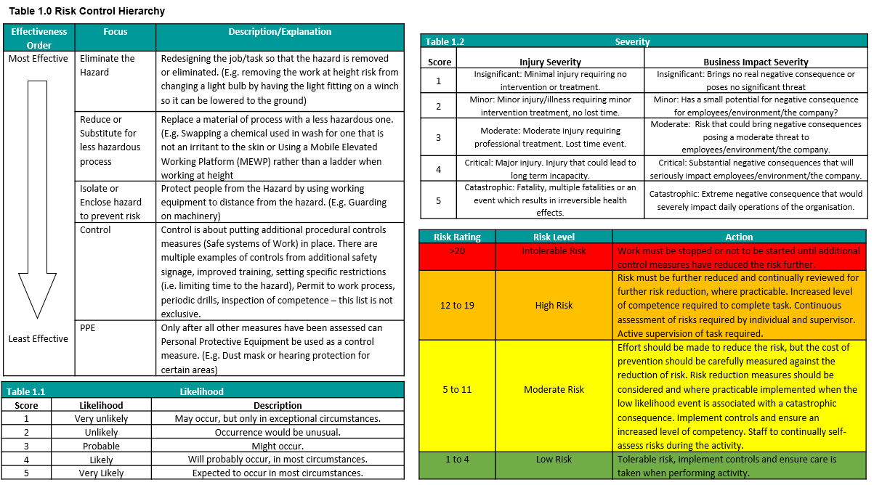

Risk Assessment Sign Off Sheet

Site Name |  | Site Manager
RA Title / Reference No. | RA003 Servicing Machinery | RA Version Number | 1
I have received training as to the hazards relating to the process/area, as outlined in the Risk Assessment and the control measures I should use to work safely. In the event of any queries I am aware I should stop work and speak to my supervisor or line manager.

Name | Signature | Date

